Algebra 1: Unit 8, Lesson 8

- Three different forms of a quadratic equation are shown.
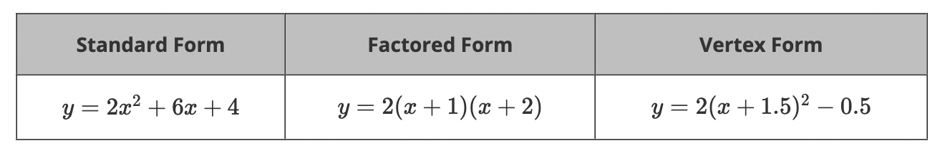
The $y$-intercept(s) is/are _____________ and can be determined by the standard form.
$$(0,4)$$

- Three different forms of a quadratic equation are shown.
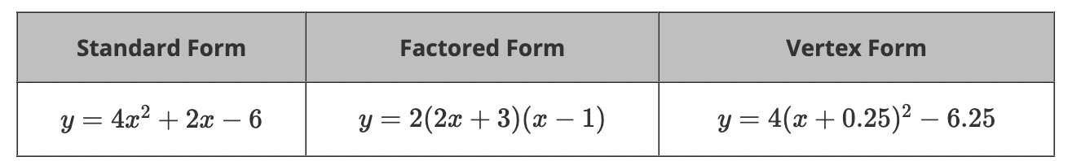
What is the vertex of the quadratic equation?
$$(-0.25, -6.25)$$

- An equation is shown.
$$F(x)=-3x^{2}+6x-5$$
Find $F(4)$.
$$-29$$

